Chapter 10, Problem 32.

Determine V_{o} and I_{o} in the circuit of Fig. 10.80 using mesh analysis.

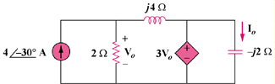

Figure 10.80
For Prob. 10.32.

